CS621 final term current Papers 2024

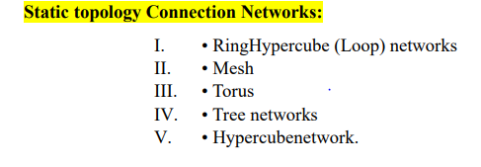
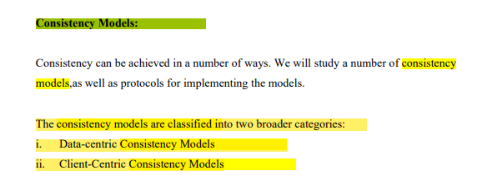
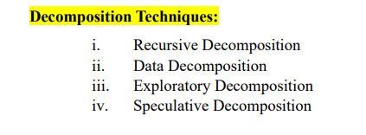

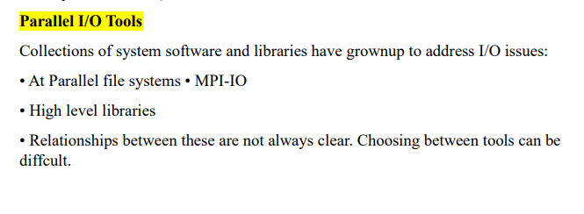

Message Passing Programming Modes:
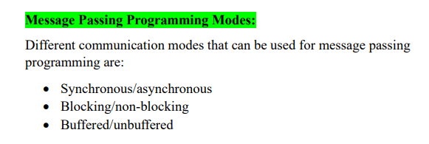

Asynchronous Message Passing:
Asynchronous Communication: An asynchronous communication completes before the message is received. It has three modes:
• Standard send: completes once the message has been sent, which may or may not imply that the message has arrived at its destination.
• Buffered send: completes immediately, if receiver not ready, MPI buffers the message locally.
• Ready send: completes immediately, if the receive

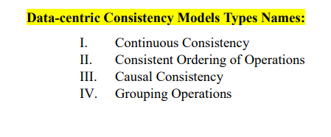
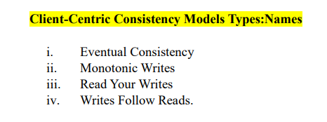

Degree of switch:

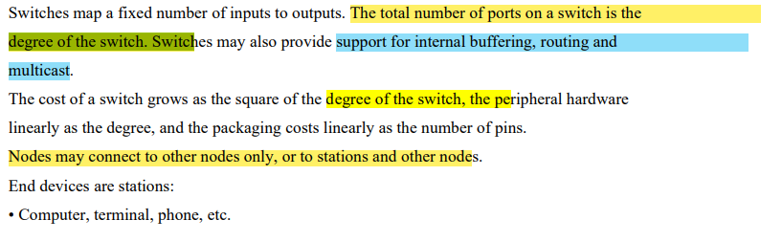
Task dependency graph:
Decomposition can be illustrated in the form of a directed graph with:
• Nodes corresponding to tasks and
• Edges indicating that the result of one task is required for processing the next.
• Such a graph is called a task dependency graph. Example of task dependency graph:
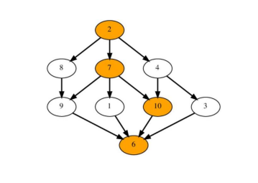
Statement btanai thi decomposition en me sy kon si ha:
Key functions of Hadoop:
• The Distribution of data and processing across machine
• Management of the cluster
Mutex-locks two states?
1. Locked and
2. Unlocked

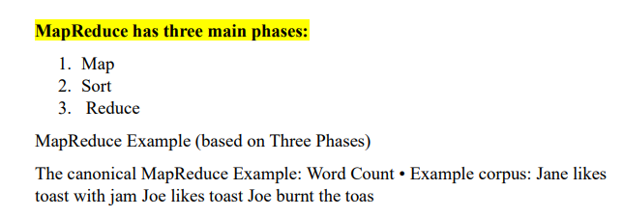

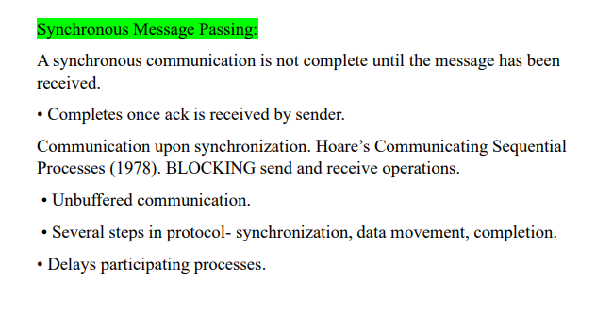
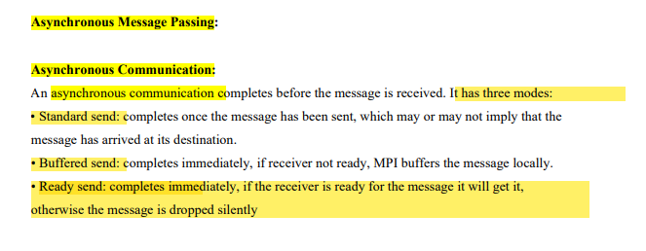

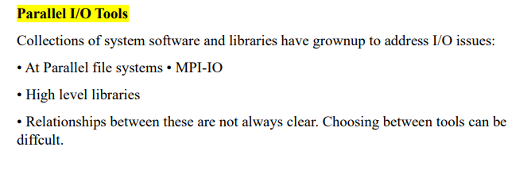
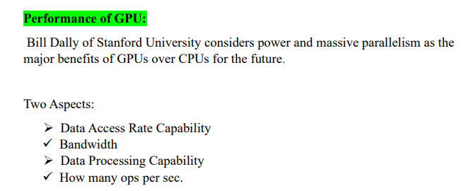
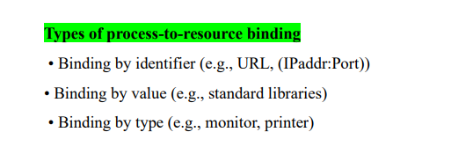
Independent MPI-IO
• For independent I/O each MPI task is handling the I/O independently using non collective calls like MPI_File_write() and MPI_File_read().
• Similar to POSIX I/O, but supports derived data types and thus non-contiguous data and non- uniform strides and can take advantages of MPI_Hints
Collective MPI-IO
• When doing collective I/O all MPI tasks participating in I/O has to call the same routines. Basic routines are MPI_File_write_all() and MPI_File_read_all()
• This allows the MPI library to do IO optimization

Advantages for Replication:
Data are replicated to increase the reliability of a system. Replication for performance:
- Scaling in numbers.
- Scaling in geographical area.
Replicas allow remote sites to continue working in the event of local failures. It is also possible to protect against data corruption. Replicas allow data to reside close to where it is used.

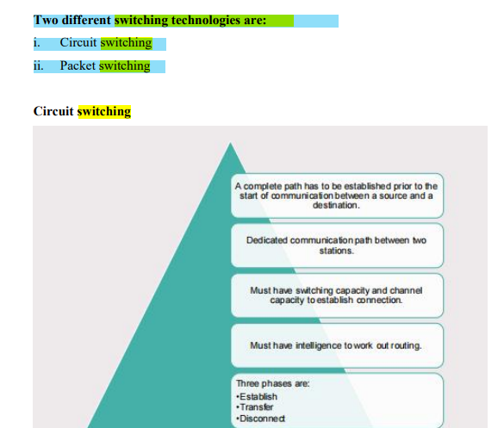
Packet switching:
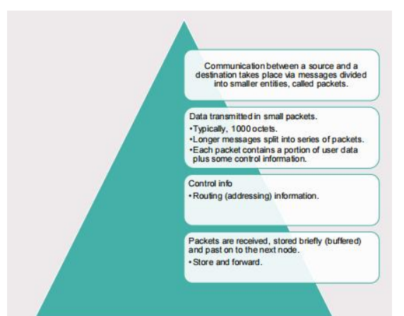

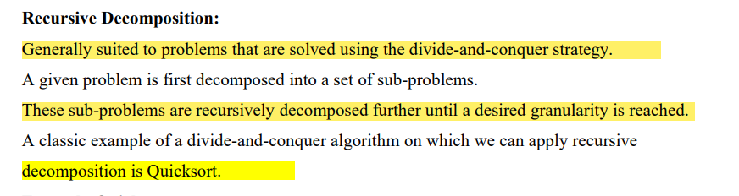
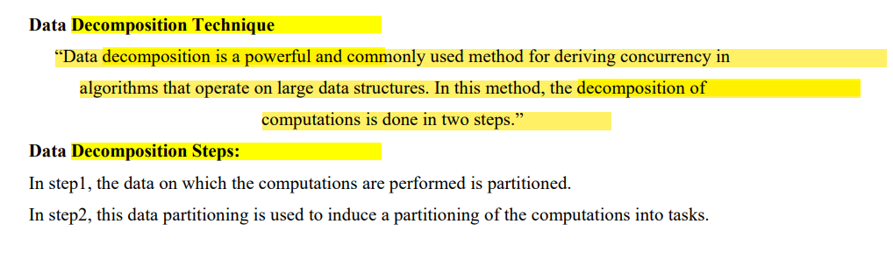

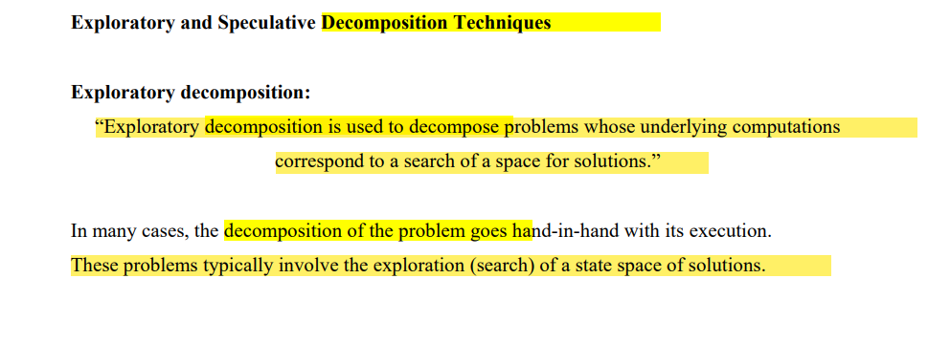
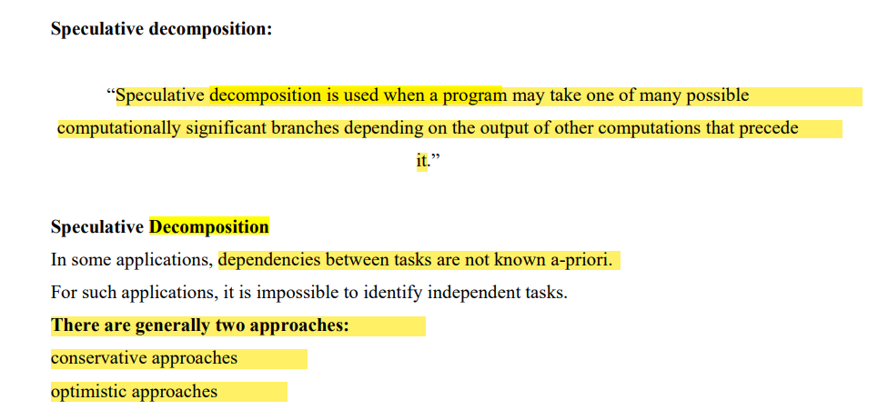

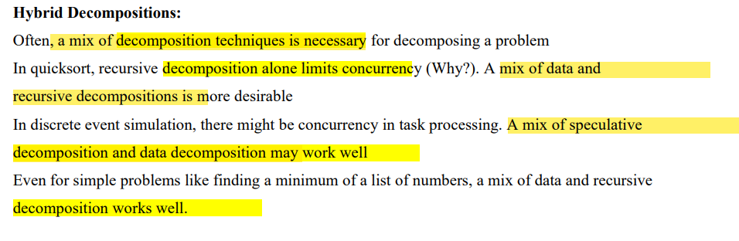
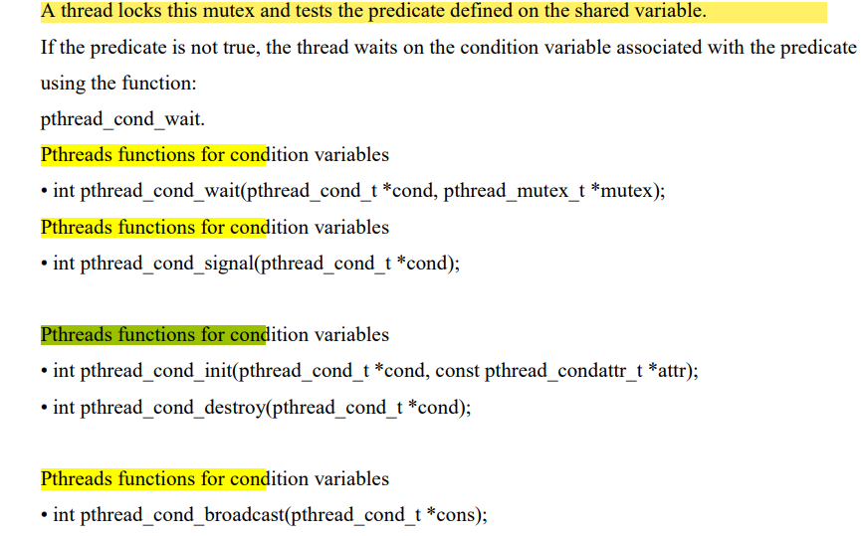

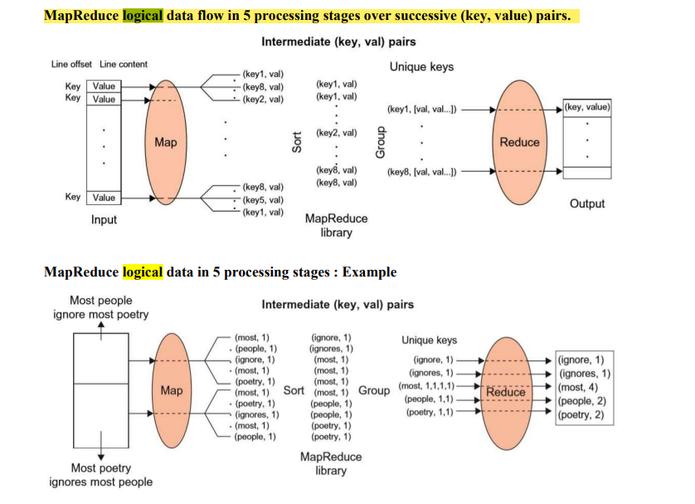

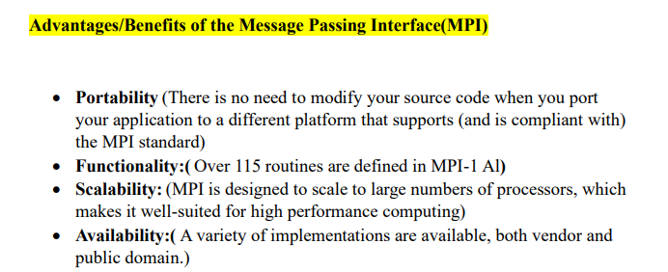
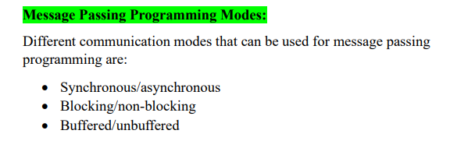
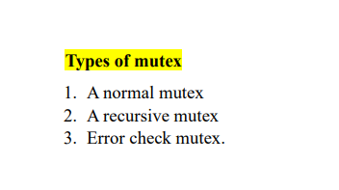
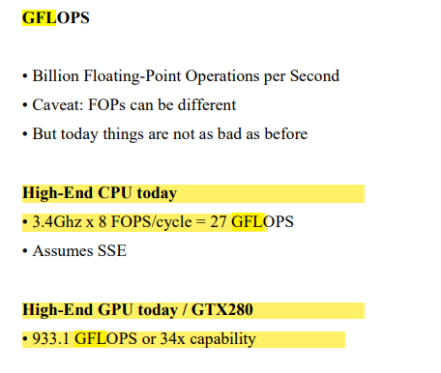
What will happen when multiple threads attempt to manipulate the same data item, if proper care is not taken to synchronize?
Can results incoherent

Hadoop Components
MapReduce and Hadoop
Hadoop
MapReduce
HDF

A sequential algorithm is evaluated by its runtime (in general, asymptotic runtime as a function of input size
Five interconnection networks in parallel and distributed networks?
- Bandwidth
- Latency
- Bisection
- Diameter
- Degree of nodes

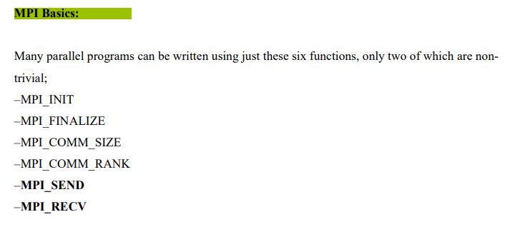
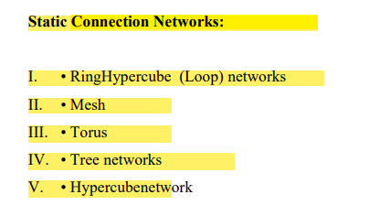

Architecture of GPU
Parallel coprocessor to conventional CPUs Implement a SIMD structure, multiple threads running the same code.
• Thread local rigister
• Block local memory and control
• Global memory

